**CHAPTER 5**

**TESTS AND RESULTS OF ROBOTIC ARM CONTROL SYSTEM**

In this chapter, tests and results for Robotic Arm Control System using Arduino Mega are described. This chapter covers hardware, software testing and results of Robotic Arm Control System using Arduino Mega. For Bluetooth Module to be ready to use, the connections of hardware devices are described.

**5.1. Tests and Results**

Figure 5.1 is the illustration that is not connected with the Bluetooth and starts switch on. With the completed hardware, this system is began testing the individual components before integrating the entire system. In this system, Arduino is also used to communicate hardware completely. The model of robotic arm control system uses Bluetooth module. Bluetooth module is used to control picked and placed of robotic vehicle.

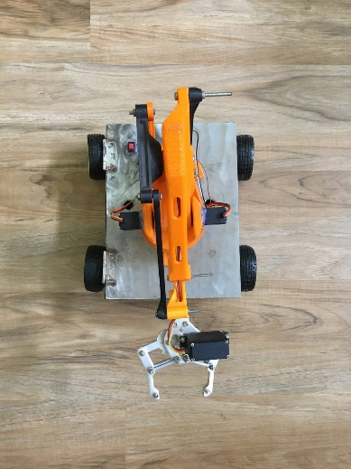

Figure 5.1. Hardware Design of Robotic Arm Control System

5.1.1. Commands of Phone Controlled Robot

Figure 5.2. is the main control of the whole system. In the beginning, the user needs to press the ‘ Devices ’ for searching Bluetooth devices and selects the device you want to connect. When the Bluetooth device is connected, the second bar of the application display ‘Connected’ and the user is able to process the functions as shown in application. The user is ready to command the functions for the car and robotic arm in detail. If the user wants to disconnect the Bluetooth device, the user needs to press ‘Disconnect’.



Figure 5.2. Commands of Phone Controlled Robot

5.1.2. Experimental Results for Turning Left and Right Direction

The phone-controlled robot consists of a robotic arm placed on a moving vehicle. Figure 5.3 shows the experimental result for turning left direction.

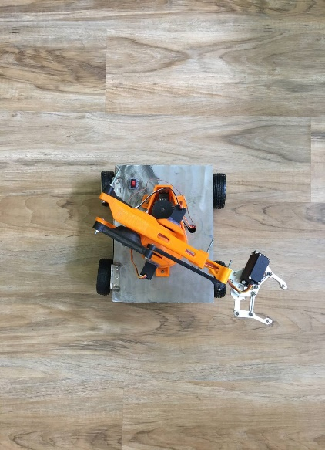

Figure 5.3. Experimental Result for Turning Left Direction

The vehicle is able to move along any type of surfaces irrespective of it is smooth or rough. The phone-controlled robot uses four DC motors for the operation. Figure 5.4 shows the experimental result for turning right direction.

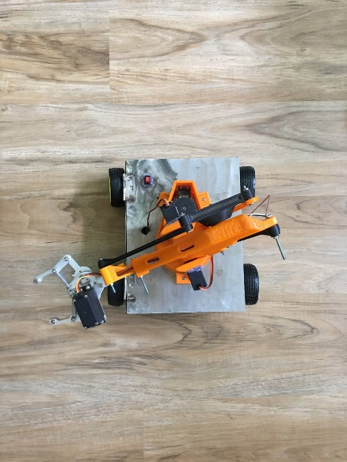

Figure 5.4. Experimental Result for Turning Right Direction

5.1.3. Experimental Results for Upward and Downward Movement

The four servo motors are used for the Picked and placed operation. The experimental result for upward movement is shown in Figure 5.5.

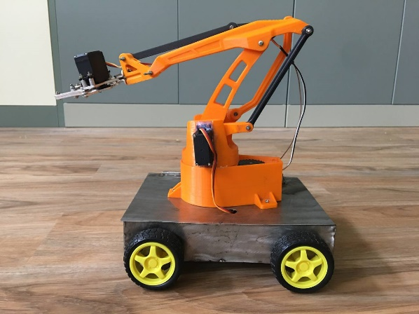

Figure 5.5. Experimental Result for Upward Movement

The picked and placed arm consists of an assembly with the claw. These four servo motors are used for the arm assembly, two for the up and down motion. The experimental result for downward movement is shown in Figure 5.6.

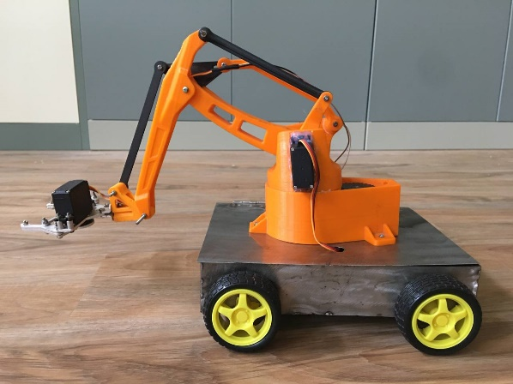

Figure 5.6. Experimental Result for Downward Movement

5.1.4. Experimental Results for Turning Left and Right with object

Among four servos, one for turning left and right and one for grip. Figure 5.7 shows the experimental result for turning left with object.

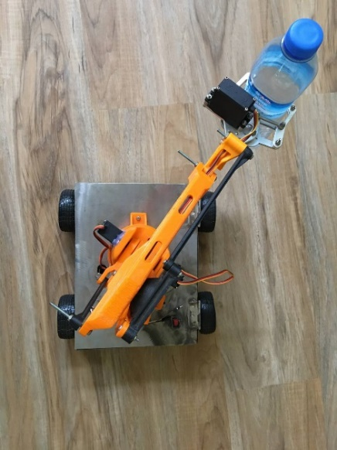

Figure 5.7. Experimental Result for Turning Left with object

Figure 5.8 shows the experimental result for turning right with object.

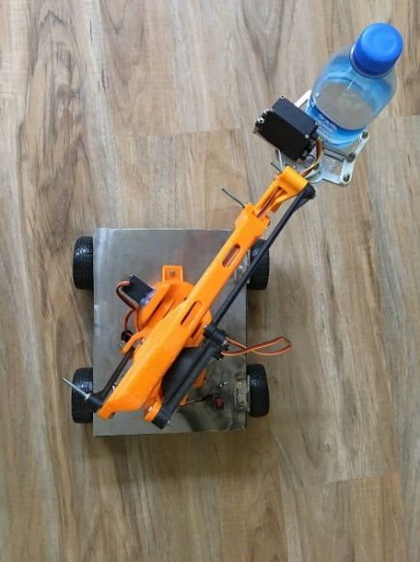

Figure 5.8. Experimental Result for Turning Right with object

**5.2 Summary**

This chapter has been described about the experimental results for turning left, right, forward and backward directions of the vehicle. Additionally, the experimental results for turning left, right, upward and downward directions of the robotic arm have been described. The next chapter will be described about discussions, conclusion and further extension.